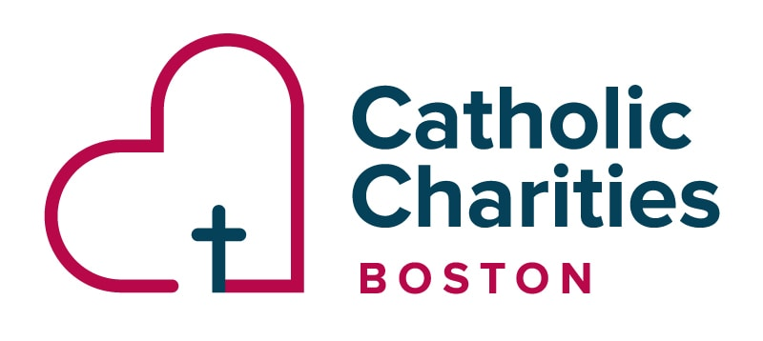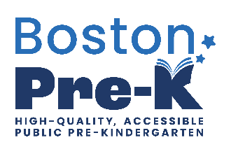

Priority Seats for Boston Pre-K at Yawkey for school year 26-27:
Preview Sessions date: Tuesday, December 9th , 2025
Session #1 8:30-9:30am
Session #2 3:00-4:00pm
The application and registration window for SY2026–2027 will open on December 13, 2025.
Boston Pre-K works with your family to make Boston Pre-K work for you.
From multiple location options, to support and specialized services for your child, we provide the best preparation and path for your child to enter kindergarten.
- All children are eligible for Boston Pre-K, as long as they turn 3 years old by September 1st of the upcoming school year and are residents of the City of Boston.
- Eligible children are entitled to specialized support and services
to meet their unique needs. This includes evaluations and Individualized Educational Plans (IEPs). Boston Pre-K works with the Office of Specialized Services at BPS or third-party partners to provide services.
- Boston Pre-K supports and screens a range of comprehensive services to set students up for success in the classroom.

*Before and After school programs are available for a fee to be determined*

Any questions, you can reach Ms. Evelyn, Family Engagement Coordinator at
evelyn_correa-gonzalez@ccab.org or
Program Director Kathleen Nichols at Kathleen_nichols@ccab.org

